 | 12.1.28 Editors - Geometry Nodes Editor - Header - Add Menu - Mesh - UV
Table of content
Detailed table of content 1
Add menu - UV 2
Pack UV Islands 2
UV Unwrap 2

Detailed table of content
Detailed table of content
Detailed table of content 1
Add menu - UV 2
Pack UV Islands 2
Inputs 2
UV 2
Selection 2
Margin 2
Rotate 2
Outputs 2
UV 2
UV Unwrap 2
Inputs 2
Selection 2
Seam 2
Margin 3
Fill Holes 3
Outputs 3
UV 3

´

Add menu - UV
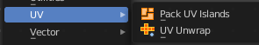
Here you find nodes to modify the UV mapping.

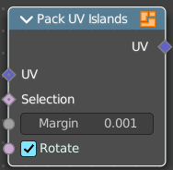
Pack UV Islands
Pack the UV islands to get the most out of the UV mapping.

Inputs

UV
The input UV geometry.

Selection
A selection of the UV geometry.

Margin
How big the gap between the single UV patches should be.

Rotate
Rotate the UV patches while packing or not.

Outputs

UV
The output UV geometry.

UV Unwrap
Unwrap the mesh to give it an UV mapping.

Inputs

Selection
Which faces of the mesh should be unwrapped.

Seam
Mark edges as a seam for unwrapping.

Margin
How big the gap between the single UV patches should be.

Fill Holes
Virtually fill holes before unwrapping the mesh. This preserves symmetry and can avoids overlaps.

Outputs

UV
The output UV geometry.

